EXPERIMENT 1

PROGRAM B – 16-bit addition and subtraction

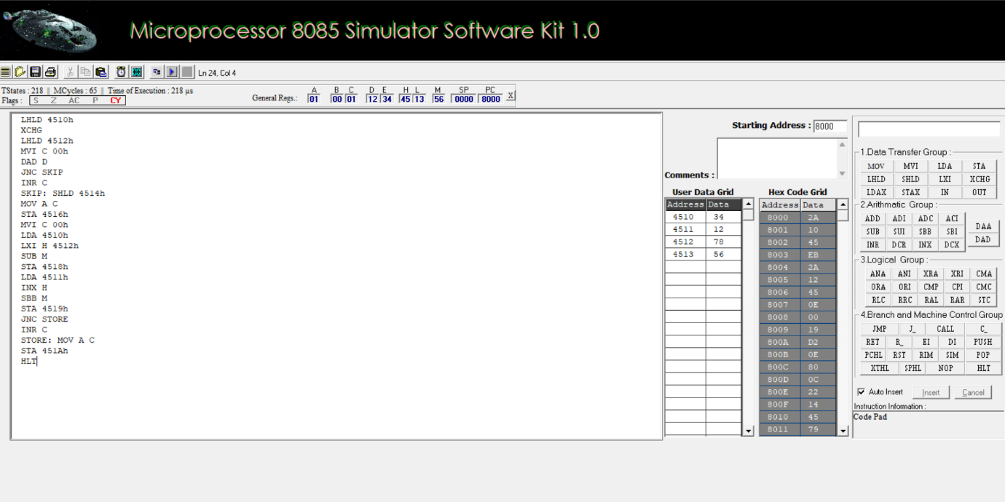

PROGRAM D – 16-bit multiplication and division

